**What does port forwarding mean and how do I do it, and what’s the deal with IP’s**

Port forwarding is opening a doorway for players outside your network to connect to your encounter+ setup. Its not hard to do once you understand the steps but there can be complications, we will look at below.

First let’s describe how you can do the configuration.

* Port forwarding: Open a web browser and type in the routers IP address in the URL bar. For example, type http://192.168.1.1 in the address bar to connect to a router that has 192.168. 1.1 as its IP address. this will take you to the router’s configurations page.

* if you have previously changed your router IP use the one you changed to instead.

Every router has a little different layout but if you find the tab in your routers menu that is called “port forwarding or “port range forwarding” you’re in the right place. It should look similar to this.

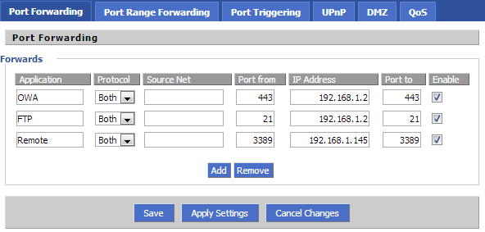

* Under application enter whatever you want to call this connection, I call is E+goodness. Under protocol enter both or tcp (tcp is what you need). Under port (or port to) enter 8080, the same for (port from). Then enable, save, and exit.

Congratulations you have forwarded a port. Now the format you need to finish up here is to make sure you are getting your players to the right address and por.

** Don’t get what an IP is? That’s ok. IP Address stands for Internet Protocol address and is an identifying number that is associated with a specific computer or computer network. Every network and every device have one.

An IP address allows computers to send and receive data over the internet. There are two types of IP addresses we care about here: public, private. Private is for inside your network so with this address others connected internally (in your house) will be able to get to the web browser view. Public is used outside of a network

A public IP looks like this: 11.22.33.44

A private ip looks like: 192.168.1.123 (generally the last three digits are the “name” of the specific device)

**SUM IT UP: private IP’s with the port forwarded will let people inside your home network get to the web client. Public IP’s with the port forwarded will let people outside your network get to the web client.**

**They will look like this Public = 11.22.33.44:8080**

**Private= 192.168.1.123:8080**

**You MUST set the IP to public if you are wanting remote players to see the web client. My examples below would ONLY work for players inside my house on my private network so you need to replace what you see below with your address that is easily obtained from** <https://whatismyipaddress.com/>

Once you have the port forwarded and the right IP’s you should be giving

Internal to your network players: <http://client.encounter.plus/?remoteHost=192.168.1.123:8080> (replace 192.168.1.123 with yours)

AND/OR

External or remote players: <http://client.encounter.plus/?remoteHost=11.22.33.44:8080> (replace 11.22.33.44 with yours)

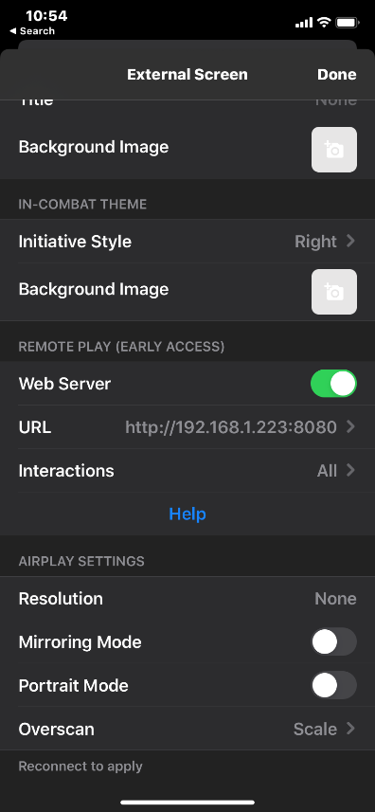 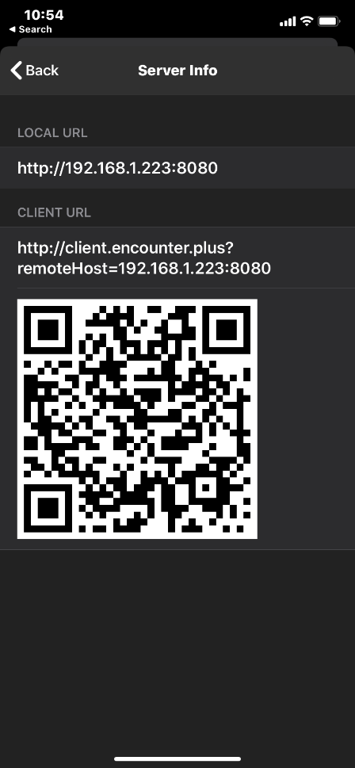

You might however say “wait a minute the address in my E+ doesn’t look anything like that, it looks like 2001:db8::8a2e:370:8080. If so, you are running IPv6 the most recent version of the Internet Protocol (IP), the communications protocol that provides an identification and location system for computers on networks and routes traffic across the Internet. If you are running dual IPv6 and IPv4 which most all are you can turn off IPv6 and that should clear things up for you. If not go to the #remote-play or #Help channels.

Hope this helps you all and happy gaming.